# Module 5-Frontend-HTML5

**Theory Assignment**

1. Difference b/w HTML & HTML5?

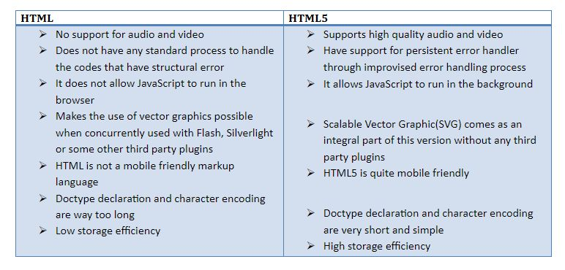

1. What are the additional tags used in HTML5?

* **Semantic Structural Tags:**
* <header>: Represents the introductory content or a group of navigational links for a section or document.
* <footer>: Defines a footer for a document or a section, typically containing information about the author, copyright data, or links to related documents.
* <nav>: Represents a section of a page that contains navigation links.
* <main>: Specifies the main content of a document, unique to that document.
* <section>: Defines a self-contained section of content within a document.
* <article>: Represents a self-contained piece of content, such as a blog post or a news story.
* <aside>: Defines content that is tangentially related to the content around it, like a sidebar.
* **Multimedia Tags:**
* <audio>: Used to embed sound content into a document.
* <video>: Used to embed video content into a document.
* <source>: Specifies multiple media resources for <video> and <audio> tags.